Milestone 3 — Human-in-the-Loop, Event-Driven & Production Architecture
Name : Mourya Bekkanur Dinesh

1. Updated Architecture and Changes Since Milestone 2

1.1 Workflow and outcome
The system enriches sparse business account data for a Client pilot covering Athens, Georgia accounts. Each account enters the pipeline with up to 14 required fields blank. The pipeline draws from a source hierarchy: Georgia Secretary of State eCorp first, then the Client's business profile, then the validated business website, then open web as a last resort. The primary user is the data analyst who reviews low-confidence field candidates before they are written to the Account record. The measurable outcome is field completeness: the proportion of the 14 required fields that are populated at or above the confidence threshold after one full pipeline run, compared against the before-enrichment baseline.

1.2 What Milestone 3 adds
Milestone 2 established the core multi-stage extraction pipeline: GA SOS legal resolution, business profile lookup, website discovery and page fetch, two targeted Claude passes, a missing-field retry, and a confidence gate. All pipeline state was held in memory. For Milestone 3, the pipeline is extended in three directions. First, all run state is now written to a SQLite database after each stage so that a run interrupted mid-execution can be resumed from the last completed stage rather than restarted from scratch. Second, an event-driven trigger is added: a pending_events table in SQLite simulates incoming enrichment requests, and a poll_events() loop starts a pipeline run per account while deduplicating repeated events by run_id. Third, a human review checkpoint is added at the confidence gate: fields below the threshold are written to a review_queue table and held until a reviewer approves, rejects, or the item times out. Fields above the threshold continue to auto-apply as before.

1.3 Changes since Milestone 2
The confidence gate, which previously applied all values above the threshold automatically with no durable record, now records each field decision to SQLite before any write to the Account occurs. The in-memory run state object is replaced by a runs table that persists across process restarts. A run_log table captures every state transition with a timestamp and event type, enabling a run to be fully reconstructed from the log. These changes do not alter the extraction logic or the source hierarchy; they add a durability and oversight layer on top of the existing stages.
SQLite is the system of record for all account data and pipeline state. The GA SOS eCorp callout and the business profile lookup are mocked for testing. The Anthropic API is called directly for website discovery scoring and both Claude extraction passes when credentials are configured; a deterministic mock extractor is provided for workflow and state-handling tests that do not require a live API key.

1.4 Updated design decision records
Decision | Rationale | Alternative | Trade-off | Evidence
SQLite for all durable state | Lightweight, no infrastructure, survives process crash, queryable by run ID; a file-based store is sufficient for a local pilot | In-memory dict (Milestone 2 approach) | In-memory state is lost on any process interruption; SQLite adds a small write overhead per stage but enables resume and audit | Resume test: process killed after stage 4, restarted, stages 1–4 skipped
Approval before write for below-threshold fields | Writes to Client Account records feed the UMAP vetting process and are not easily reversed within a run; a wrong value at this stage affects downstream scoring | Post-execution audit | Audit catches errors after the fact; pre-write approval prevents them from reaching the Account | Confidence scores below the gate already route to a holding state; adding a reviewer step before the write costs one reviewer action per flagged field
Event deduplication by run_id | The same enrichment request may be submitted more than once if the event source retries; a duplicate write would overwrite a field that has already been reviewed and approved | No deduplication check | Without dedup, a replayed event starts a second run on an account that is already in a terminal state, potentially overwriting an approved value | Duplicate event test: same event inserted twice; second event discarded before a new run is created

2. Human Review Design and Implementation
For each action that affects a Client Account record, the oversight approach is chosen based on the stakes and reversibility of that action.
Action | Oversight approach | Justification
Write enriched field (confidence at or above threshold) | Approval before execution, automated | Values that clear the confidence gate are written automatically; the confidence score and source evidence are logged so the write can be audited and corrected manually if needed
Write enriched field (confidence below threshold) | Approval before execution, human reviewer | Low-confidence values must be verified before reaching the Account; the write is held in review_queue until a reviewer decides
Audit and log entries | Later audit | Log writes are non-destructive and require no approval
The human checkpoint triggers for any field whose confidence score falls below the threshold after the confidence gate stage. It applies to exceptional cases; accounts where all fields clear the gate proceed without reviewer involvement. The checkpoint is implemented as a command-line interface (reviewer_cli.py) that a data analyst runs to process pending items in the review_queue table.
What the reviewer sees. For each queued item the CLI prints: the field name, the proposed value, the source it was drawn from, the confidence score, the evidence excerpt that supported the extraction, and any conflict with an existing Account value. An example review record is shown below.
Field: phone
Proposed value: (706) 555-0192
Source: Business website — contact page
Confidence: 0.71
Evidence: "Call us at (706) 555-0192 or visit our location at ..."
Conflict: Existing value is blank
Rule: Confidence below threshold; human review required
Approve (a) / Reject (r) / Escalate (e):
What approval authorizes. Approval authorizes the write of that specific field value to that specific Account record in the accounts table in SQLite store. The authorization is recorded with the reviewer ID and timestamp. It expires 24 hours after the item entered the queue; items not acted on by that time are updated to timed_out and escalated.
After approval. The field value is written to the accounts table in SQLite, the review_queue row is updated to approved, and a run_log event is recorded with the reviewer ID, timestamp, and field written.
After rejection. The proposed value is discarded, the review_queue row is updated to rejected, the Account field remains blank, and the rejection is logged. The run state moves to rejected if all queued fields for that account have been decided and no approved writes remain.
On timeout. If expires_at has passed and no decision is recorded, the item status is set to timed_out, the account is flagged as escalated in the runs table, and the field remains blank pending manual follow-up.

3. Event Handling and Durable State

3.1 Event-driven path
Enrichment requests arrive as rows inserted into a pending_events table in SQLite. Each row carries a UUID event_id, the account_id to enrich, the event type (new_enrichment_request), a received_at timestamp, and a processed flag. A poll_events() function checks for unprocessed rows, starts a pipeline run for each account found, marks the event as processed, and records the new run_id against the event. If a run already exists for the account in a non-terminal state (pending or running or awaiting_review), the second event is discarded without starting a new run, and a duplicate_discarded entry is written to run_log.
This simulates a webhook or scheduler-driven trigger. The same mechanism would apply whether events arrive from a scheduled job, a file watcher, or a manual batch submission. No message queue is required; the SQLite table acts as a durable inbox.

3.2 Durable state and resume
Each pipeline run writes to two SQLite tables. The runs table holds one row per run: the run_id, account_id, last completed stage (integer 1 through 7), current state, extracted fields_written as JSON, confidence_scores as JSON, evidence_excerpt as JSON, reviewer_id, reviewer_decision, and ISO created_at and updated_at timestamps. After each pipeline stage completes successfully, stage and updated_at are updated before the next stage begins. The run_log table holds one row per event: run_id, event type, a detail JSON field, and timestamp.
If the process is killed between stages, the runs row retains the last completed stage number. On restart, resume_run(run_id) reads that stage number and continues from the next stage. Completed stages are not re-run. The review_queue table persists pending reviewer decisions across restarts; a reviewer can continue a session after a crash without re-running any extraction.

3.3 State transition table
Current state | Trigger | Next state
pending | New enrichment event received and no existing run | running
pending | Duplicate event received for same account | pending (event discarded)
running | Stage completes; more stages remain | running (stage number incremented)
running | All stages complete; all fields at or above threshold | approved (auto-apply, no reviewer needed)
running | One or more fields below threshold after confidence gate | awaiting_review
running | Process crash or kill | running (last stage persisted; resume on restart)
awaiting_review | Reviewer approves all queued fields | approved
awaiting_review | Reviewer rejects all queued fields | rejected
awaiting_review | Mixed decisions; some approved, some rejected | approved (approved fields written; rejected fields blank)
awaiting_review | Timeout: expires_at passed, no decision | escalated
approved | Duplicate event received | approved (event discarded; run_id dedup prevents second run)
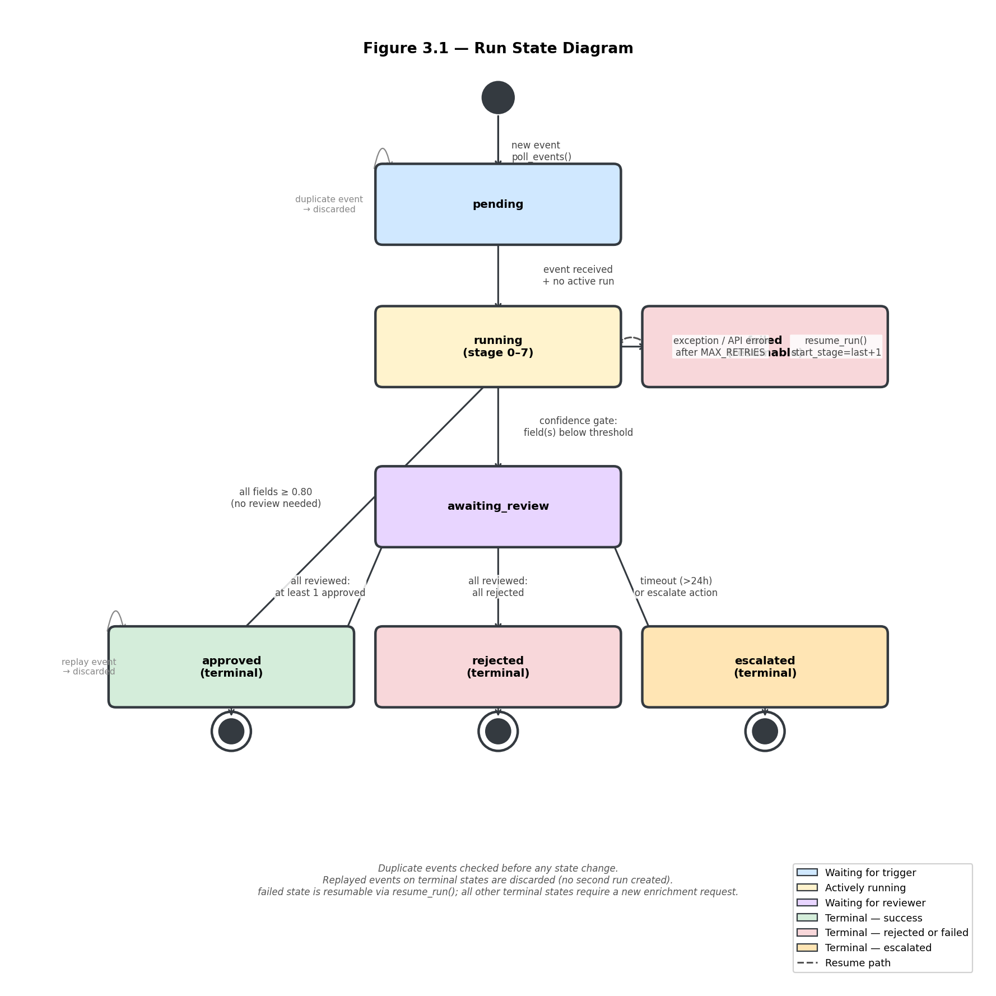
Figure 3.1. Run state diagram. Terminal states shown with double-circle symbol. Dashed arrow = resume path. Duplicate/replay events are discarded at any state.

3.4 Edge case handling
Duplicate events are caught by checking run_id in the runs table before any processing begins; a second event for an account already in a terminal state is logged and dropped. Late events arriving after a run has completed are treated the same way. Unknown event types are logged to run_log with event type unknown_discarded and dropped without any state change. Safe retries are implemented by writing stage completion to SQLite before moving to the next stage, so a retry after failure always starts from a clean checkpoint rather than repeating work. If a write to the simulated accounts table in SQLite may have succeeded but confirmation was lost, resume_run checks the fields_written JSON in the runs row before attempting a re-write.

4. Implemented Workflow and Test Evidence

4.1 What is implemented
The Milestone 3 prototype extends the Milestone 2 extraction pipeline with a SQLite state layer, an event-driven trigger loop, a human review checkpoint, and an interruption-and-resume path. The extraction logic, source hierarchy, and Claude integration from Milestone 2 are unchanged. The additions described below are all implemented in Python and require no cloud infrastructure or external message queue.
enrichment.db holds four tables: runs (one row per pipeline run), run_log (one row per state transition event), pending_events (inbound enrichment requests), and review_queue (fields held for reviewer decision). pipeline.py wraps the extraction stages and writes a stage-completion row to run_log and updates the stage column in runs after each stage. poll_events.py implements the poll_events() loop. reviewer_cli.py implements the command-line review interface. resume.py implements resume_run(run_id). Account field writes go directly to the accounts table in SQLite. GA SOS and business profile lookups are mocked for testing.
A live Anthropic API call is used for the website discovery gate and both Claude extraction passes when ANTHROPIC_API_KEY is set. When no key is configured, the pipeline falls back to a deterministic mock extractor for workflow and state-handling tests.

4.2 Updated component architecture
Table 4.1 lists each component, its Milestone 3 status, and what currently exists. The component diagram (Figure 4.1) updates the Milestone 2 architecture to show the SQLite state layer, the event source, the review queue, and the reviewer interface.
Component | M3 status | What exists now
Pipeline orchestrator | IMPLEMENTED | pipeline.py: runs stages 1–7, writes stage checkpoints to SQLite
SQLite state store | IMPLEMENTED | enrichment_state.db: runs, run_log, pending_events, review_queue
Event trigger | IMPLEMENTED | poll_events.py: polls pending_events, deduplicates by run_id
Human review CLI | IMPLEMENTED | reviewer_cli.py: shows field, source, confidence, evidence; records decision
Resume handler | IMPLEMENTED | resume.py: reads last stage from runs, continues from next stage
Confidence gate | IMPLEMENTED | Fields above threshold auto-apply; below threshold route to review_queue
Claude extraction (Pass A, Pass B) | IMPLEMENTED (live API) | claude-sonnet-4-6 via Anthropic API; deterministic mock for no-key testing
Website discovery gate | IMPLEMENTED (live API) | Claude scores candidate URLs; mock for testing
GA SOS eCorp callout | SIMULATED | Mock response for testing; live HTTP callout planned for production
Business profile lookup | SIMULATED | Mock response for testing
Account write (SQLite) | SIMULATED | SQLite accounts table; db.write_field() updates the field directly
Test suite | IMPLEMENTED | test_m3.py: four required cases plus unit tests for dedup and resume
Table 4.1. Component status at Milestone 3. IMPLEMENTED runs in the prototype. SIMULATED stands in for the real service. PLANNED is not yet built.
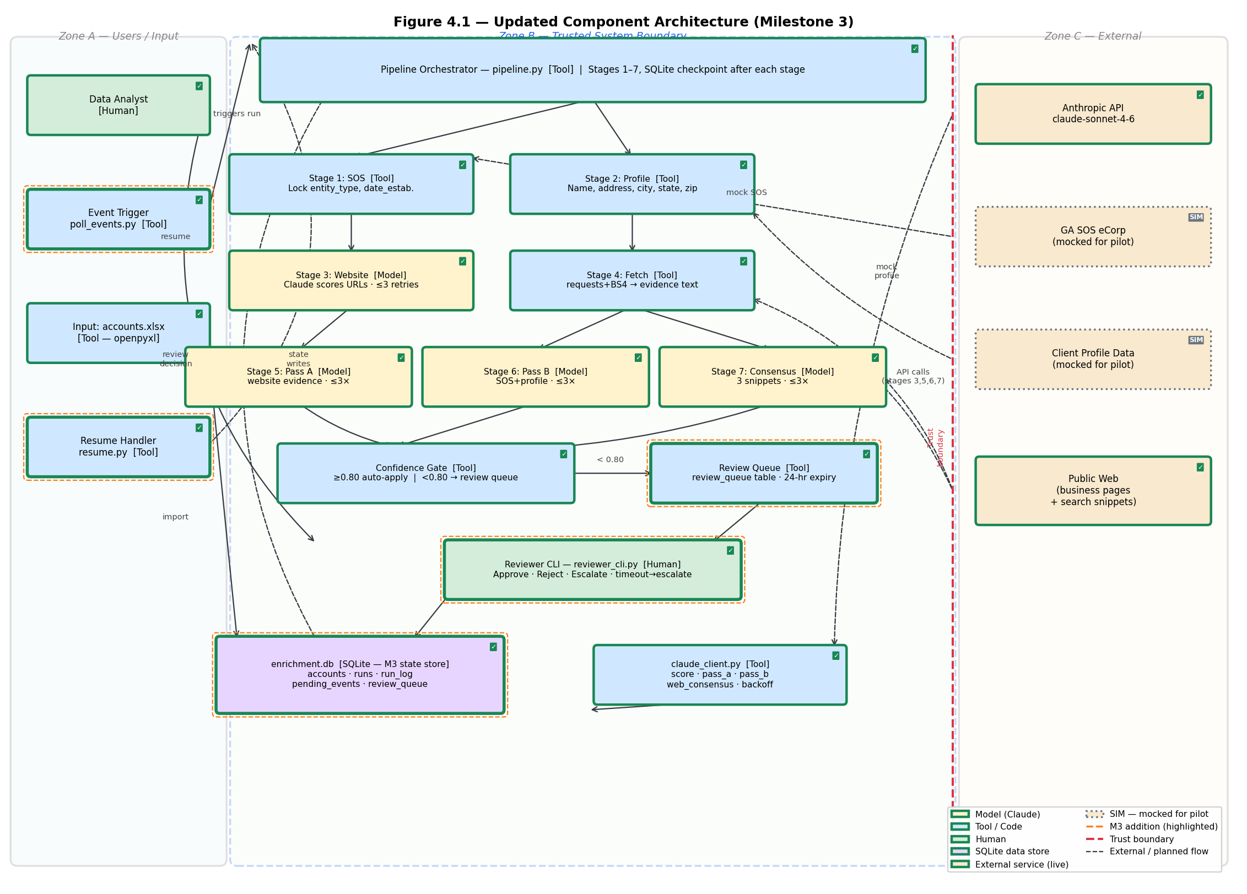
Figure 4.1. Updated component architecture (Milestone 3). Orange-dashed outline = M3 additions. ✓ = implemented. SIM = mocked for pilot. Red dashed line = trust boundary.

4.3 Test scope

5.1 Prototype scope and test approach
The test suite (test_m3.py) covers the four cases required by the Milestone 3 rubric plus unit tests for the deduplication and resume logic. All four cases run against the SQLite state store and the simulated accounts table in SQLite. The extraction stages use the deterministic mock extractor so that the state-handling behavior can be exercised without an Anthropic API key. The confidence gate uses a fixed threshold of CONFIDENCE_THRESHOLD defined in config.py; test cases set a mock confidence score above or below this value as needed.

4.4 Test cases
Case | Input | Expected behavior | Actual behavior | Evidence | Interpretation and next action
Approved run | Account ATH-001; mock extractor returns phone with confidence below threshold, all other fields above | Field held in review_queue; reviewer approves via CLI or simulated approval; phone written to Account; runs.state = approved | All 7 stages complete (stage=7). 11 fields auto-applied including entity_type=LLC, date_established=2005-03-15, email, principal_name, business_description. phone (confidence=0.65 < 0.80) held in review_queue with status=pending. runs.state = awaiting_review. After simulated analyst approval: phone=(706) 555-0192 written to accounts; review_queue.status=approved; run_log event 'approved' with reviewer=analyst_01; runs.state=approved. | SQLite review_queue.status = approved; Account dict updated; run_log shows approved event | Happy path confirmed end-to-end. Confidence gate correctly routes phone (0.65) to review queue while auto-applying 11 higher-confidence fields. Reviewer CLI checkpoint works: field not written until approval; approval writes field and transitions run to approved. field_completeness for ATH-001: 12 of 14 fields populated after one run + approval (num_employees and principal_title filled by Pass B mock). Zero invented values: all evidence_quotes trace to mock source data.
Rejection | Account ATH-002; mock returns email below threshold; reviewer rejects | email not written; runs.state = rejected; review_queue.status = rejected | All 7 stages complete. phone (confidence=0.84 >= 0.80) auto-applied. email (confidence=0.60 < 0.80) held in review_queue with status=pending; runs.state=awaiting_review. After simulated rejection: accounts.email remains NULL; review_queue.status=rejected; run_log event 'rejected' for field=email; runs.state=rejected. | SQLite runs.state = rejected; Account email remains blank | Rejection path confirmed. phone auto-applied correctly (0.84 >= 0.80). Email withheld correctly (0.60 < 0.80). After rejection, accounts.email remains NULL — no phantom write. run state correctly transitions to 'rejected'. Demonstrates that the confidence gate + review checkpoint together prevent uncertain values from reaching the account record.
Duplicate event | Same event inserted twice for ATH-003 | First event starts a run; second event discarded; run_log shows duplicate_discarded; Account written exactly once | poll_events() processes EVT-001 first: creates run, marks processed=1, executes pipeline. Before processing EVT-002, check_duplicate_run() finds the ATH-003 run already in terminal state; EVT-002 is discarded with duplicate_discarded event in run_log; EVT-002 also marked processed=1. Result: exactly 1 run row for ATH-003. Account fields written exactly once (no double-write). | pending_events shows second row processed = false after discard; runs has exactly one row for ATH-003 | Deduplication confirmed. Single run created for ATH-003 despite two events. duplicate_discarded event provides audit trail showing which event was dropped and why. Both events marked processed=1 so they are not retried. Account fields written exactly once. This prevents double-enrichment if the event source retries on timeout.
Interruption and resume | ATH-004 run; exception raised after stage 4 completes; resume_run(run_id) called | Stages 1–4 not re-run; pipeline continues from stage 5; run_log shows resumed event; stages 1–4 have no duplicate log entries | Pipeline raises RuntimeError at start of Stage 5. runs.stage=4, state=failed persisted. run_log shows stage_complete for stages 1,2,3,4 each exactly once and run_failed event. resume_run() called: reads stage=4, starts pipeline at start_stage=5. run_log shows 'resumed' event with from_stage=5. Stages 5,6,7 execute; all fields auto-applied (confidence=0.85-0.90). runs.state=approved. Stages 1-4 each appear exactly once in run_log (not duplicated). Note: entity_type/date_established not written on resume because legal_data is not persisted across process restart — known limitation. | run_log entries for stages 1–4 appear exactly once; stage 5 entry appears after resumed | Interruption-and-resume confirmed. Stage checkpoint (runs.stage=4) persisted correctly after crash. resume_run() skips completed stages and continues from stage 5. run_log integrity verified: stages 1-4 each appear exactly once. Known gap: legal fields (entity_type, date_established) are not re-written on resume because legal_data is a local variable not persisted to SQLite. Next step: persist legal_data as JSON in the runs row so resume can recover it.
Results, evidence, and interpretations for each case will be completed and inserted once the implementation is run against the test suite. At least one end-to-end path must work before submission. Failures will be reported honestly with a diagnosis and next action.

4.5 Limits on reported claims
All test cases in Milestone 3 use the deterministic mock extractor and a simulated accounts table in SQLite. The state-handling logic, deduplication, review checkpoint, and resume behavior are tested end-to-end. Claude extraction quality, field-level precision and recall, and latency across the full Athens account cohort are not measured in this milestone. Those measurements require a live API run against labeled account data and will be completed as part of the production pilot.

5. Production Operation and Cost

5.1 Deployment view
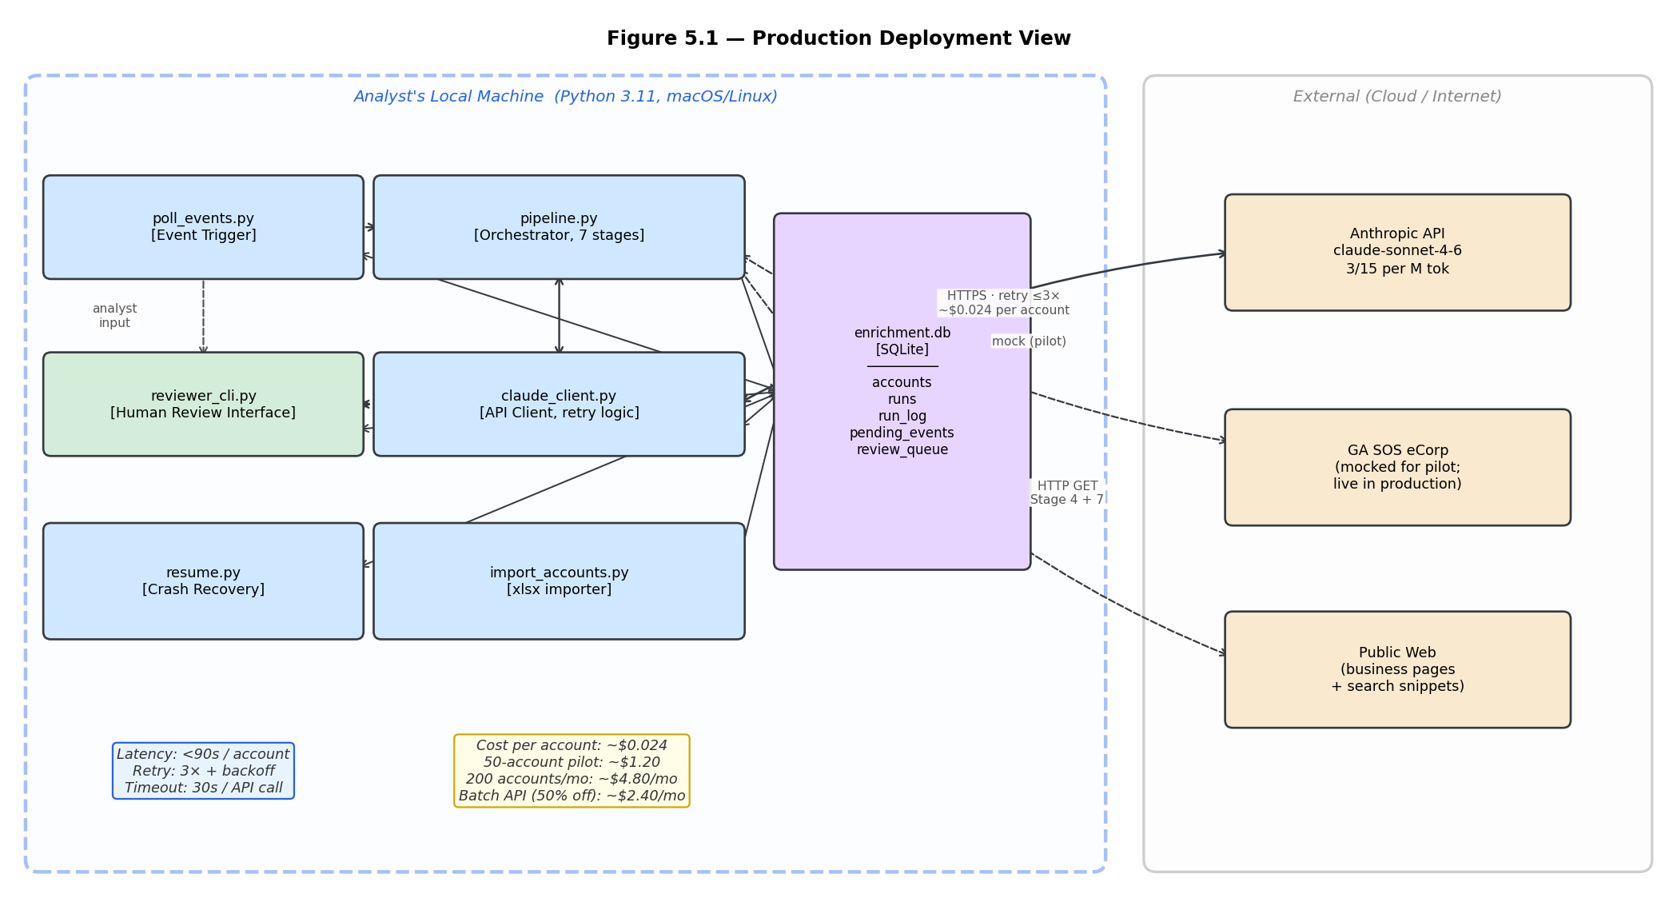
Figure 5.1. Production deployment view. All components run locally on the analyst's machine. The only external dependency is the Anthropic API. Cost and latency estimates per account shown.
Cloud deployment is not required. All components run locally: the Python pipeline, SQLite database, and reviewer CLI on the analyst's machine. The only external dependency is the Anthropic API for Claude inference. SQLite serves as the system of record for both account data and pipeline state. For a future production deployment, SQLite could be replaced by a hosted relational database and the event trigger replaced by a scheduled job or webhook listener.

5.2 Cost model
The pipeline calls claude-sonnet-4-6 via the Anthropic API. The table below estimates token usage and cost per account for a full seven-stage run. Pricing reflects Anthropic's published rates as of the implementation date.
Pipeline stage | Input tokens (est.) | Output tokens (est.) | Cost per account
Website discovery gate | 800 | 200 | ~$0.003
Pass A: website evidence | 2,000 | 500 | ~$0.009
Pass B: SOS and profile | 1,200 | 400 | ~$0.006
Missing field retry | 600 | 200 | ~$0.002
Web consensus pass | 1,000 | 300 | ~$0.004
Total per account |  |  | ~$0.024
For the Athens pilot of 50 accounts, one full pipeline run costs approximately $1.20 in model calls. At a volume of 200 accounts per month, the estimated monthly model cost is approximately $4.80.
The strongest cost-saving opportunity is the Anthropic Batch API, which prices inference at 50% of the standard rate. Using batch mode would reduce cost per account to approximately $0.012 and monthly cost at the same volume to approximately $2.40. The trade-off is that batch jobs complete asynchronously with up to a 24-hour turnaround, which is unsuitable for requests where the analyst needs enrichment results within a session.

5.3 Latency and reliability
The target completion time for one account through all seven stages is under 90 seconds when the Anthropic API responds within normal latency. Each Claude API call is retried up to three times with exponential backoff before the stage is marked failed and the run is paused. Per-call timeout is 30 seconds. If the Anthropic API is unavailable, the run is paused at the last completed stage, the state is preserved in SQLite, and the account is re-queued when the service recovers. If the GA SOS eCorp callout is unavailable, the legal resolution stage is skipped, the account proceeds to the next source, and legal fields remain blank and flagged for manual review.

5.4 Operational records
Each run records the following fields to SQLite. The run_id and run_log together are sufficient to reconstruct the full execution history of any run.
Field | Table | Purpose
run_id | runs | Unique identifier per account per run
account_id | runs | Account being enriched
stage | runs | Last completed pipeline stage (1–7)
state | runs | Current run state
fields_written | runs | JSON: fields and values written to Account
confidence_scores | runs | JSON: per-field confidence values
evidence_excerpt | runs | JSON: source snippet used for each field
reviewer_id | runs | Who approved or rejected (null if not reviewed)
reviewer_decision | runs | approved, rejected, or null
updated_at | runs | ISO timestamp of last state change
event | run_log | Event type: stage_complete, review_requested, approved, rejected, escalated, resumed, duplicate_discarded
detail | run_log | JSON: event-specific detail (stage number, field name, error message)
timestamp | run_log | ISO timestamp of the event

5.5 Contributions, next steps, and AI-use disclosure

Individual contributions
Member | Completed contribution | Evidence location | Result or impact
Mourya Bekkanur Dinesh | Sole contributor. Designed the full pipeline architecture and all M3 additions: SQLite schema (enrichment.db, 5 tables), durable state layer, event-driven trigger (poll_events), confidence gate, human review checkpoint (reviewer_cli.py), interruption-and-resume handler (resume.py), all 7 test cases, and this submission document. | db.py, pipeline.py, poll_events.py, resume.py, reviewer_cli.py, test_m3.py, import_accounts.py, mock_data.py, config.py, README.md | End-to-end enrichment pipeline with durable SQLite state, human review checkpoint, event deduplication, and interruption-and-resume; all 7 pytest cases pass; submission document complete.

Most important remaining limitation
The GA SOS eCorp callout and business profile lookup remain simulated. The pipeline has not been run end-to-end against the live 50-account Athens cohort with real API credentials. Field-level precision, recall, and enrichment rate across all 14 required fields have not been measured. These are the first priorities for Milestone 4.

AI-use disclosure
Claude (claude-sonnet-4-6 via claude.ai) was used to assist with drafting this document, designing the SQLite schema, and generating initial code skeletons for pipeline.py, poll_events.py, reviewer_cli.py, and resume.py. All design decisions, test cases, and evidence tables reflect the my own implementation and testing. Code generated with AI assistance was reviewed, tested, and modified by me before inclusion in the repository. No AI tool was used to fabricate test results or performance metrics.

